O365/AZURE: PowerApps-Flow-POwerBI

Shift Activity Logger

# AS A – I WANT – SO THAT

Business Domain/Environment background: This is a kind of Services/Utilities Industry scenario, where a fixed-management-structure with Regional-Site Managers + Site-Shift Managers + Site Workers and other higher management – but, below analysis would describe what each role wants to achieve in the context and process journey to be able to produce a report that helps giving a traceability of activities and time-tracking performed – for more auditable/reliable billing to the customers of this potentially! honest/professional/compliant/productivity-efficient Services-Company – who wants to bring up profits and only do enough work for what they are being paid for!!

1. **AS A**: APP ADMIN/SUPERUSER
   1. – **I WANT**: Ability to enter master-data in SharePoint lists – **SO THAT:** such data, drives as many decisions/flows as possible. “Employees” data and configuration, “Building” and “Projects” master data should be maintained.
   2. – **I WANT**: Least data entry possible to make the application work on day2day basis, including transaction-data-recycling/retention policies etc. – **SO THAT:** the system operates like clock-work!
2. **AS A**: SHIFT LEAD/MANAGER
   1. – **I WANT**: To see a list of daily timesheet records ready and available for entering necessary information (as will be elicited thorough analysis) with ability to draft EDITS, REVIEW and SUBMIT for publishing – **SO THAT:** for each worker assigned under/inside my watch/shift/care can be tracked for their time/resources spent on specific/BAU tasks – without needing to “create” a record every day and pick workers and all that.
   2. – **I WANT**: To delegate and co-share my task of filling in timesheets with some other Shift-Leads on SITE or other sites, in case of my absence or in cases where worker is interim posted on other site– **SO THAT:** the workflow process is flexible, and it provides the worker with support/management from other Shift-Leads.
3. **AS A**: SHIFT WORKER
   1. – **I WANT**: To enter my timesheets on regular basis and daily and capture additional digital resources in support of the timesheet and save-submit – **SO THAT:** My Lead can review/remind to maintain my time keeping and trackability on different projects.
4. **AS A**: REGIONAL (REPORTS) MANAGER
   1. – **I WANT**: To produce/generate a report (Power-BI) on weekly/regular basis and send out (print/export) such reports to appropriate regional-managers and clients – **SO THAT:** It can produce transparent and up to date reporting and billing.
5. **AS A**: PROCESSES MANAGER (SYSTEM)
   1. – **I WANT**: Once a SAL is submitted/approved and report data is generated, it can only be Viewed or Printed – but not edited. Except by an Admin/Support/Escalation permission level member - to change anything about the SAL record like adding/removing hours, rectifying any typo-errors etc. And after a certain period (usually Report pull cycle) - **No changes or deletion can be made**. Hence, it is possible to mark the list item as a record and IRM policies can be used to manage the data lifetime and audit requirements. – **SO THAT:** Records management, governance and auditing can be maintained.
   2. – **I WANT**: A potential automation/flow that triggers on Employees list to manage permissions to SharePoint groups etc. Basic SharePoint groups can be ShiftLead, EscalationSupportTeam and EmployeeWorkers
   3. – **I WANT**: To send out remind-notifications to appropriate Shift-Lead-Managers – **SO THAT:** They can complete and submit all the weekly time-keeping records for above reporting.

# Solution ApProach

* DATA: Information Architecture – Content Types, Lists, Libraries (PnP Provisioning PowerShell)
* FORMS: Power Apps (With Offline)
* AUTOMATION: Azure-Logic-Apps/Azure-Web-Jobs-Functions/MS-Flows
* REPORTS: Power BI
* CUSTOM: SPFX-Web-Parts | SPFX-Extensions
* To maintain the data in SharePoint (initial migration will be facilitated by one-off script (PowerShell/Flow with Excel).
* A **PowerApps** solution with multiple screens and programmatic elements including connections to Flow will needed since there would be application-level data processing where end-users do not have access to SharePoint lists. To extend this app – SPFX Web Parts and/or Extensions may be coded.
* One or more **MS-Flow/Logic-App** will be defined to process information and facilitate PowerApps (* challenge will be the JSON bit) would be required.
* For reporting **Power-BI** will be employed to connect to SharePoint list and process data from there (*challenge work-around is the JSON bit).

# SOLUTION DESIGN

|  |  |
| --- | --- |
| **Schema and Data from Illustrative Business** | **(Raw):** |
| **PnP Provisioning PowerShell** | $siteUrl = "https://appflowitjan2019.sharepoint.com/sites/sal"  Connect-PnPOnline -Url $siteUrl -Credentials (Get-Credential)  **## Get-PnPProvisioningTemplate -Out ("{0}\{1}.xml"-f 'D:\Code\SAL\pnpprovision', "site_sal_pnptemplate") -IncludeAllTermGroups**  **Apply-PnPProvisioningTemplate -Path ("{0}\{1}.xml"-f 'D:\Code\SAL\pnpprovision', "site_sal_pnptemplate") -ClearNavigation**  Read-Host -Prompt "Press Enter to exit…" |
| SharePoint Farm Solution |  |
|  |  |

## DATA - Infomration Architecture

### Site Columns

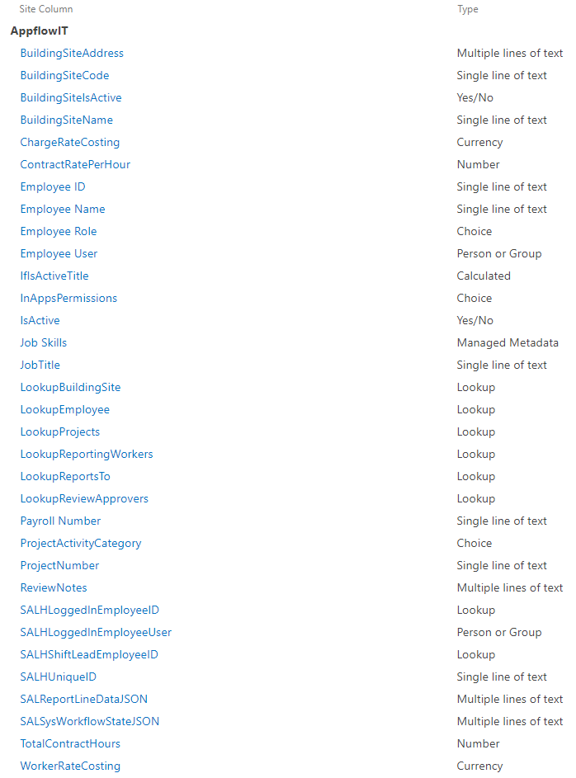

### Content Types

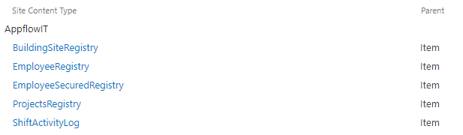

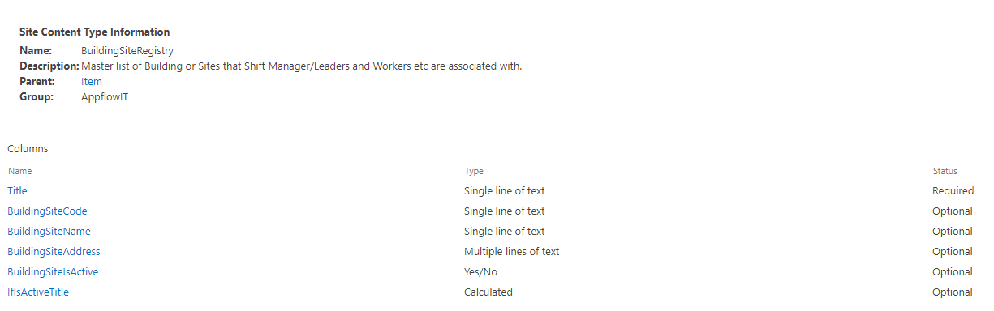

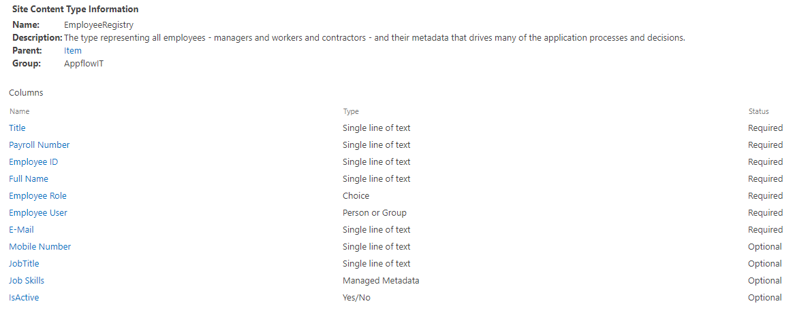

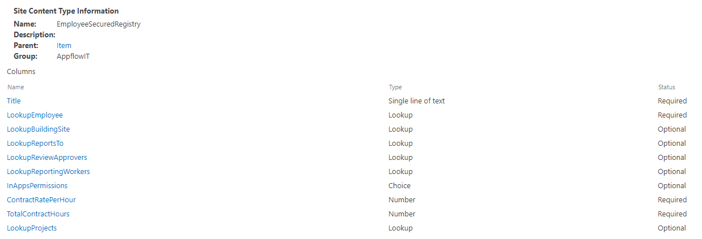

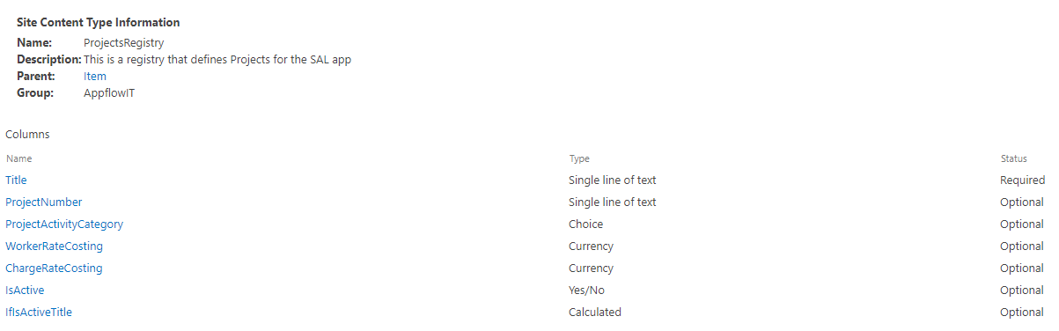

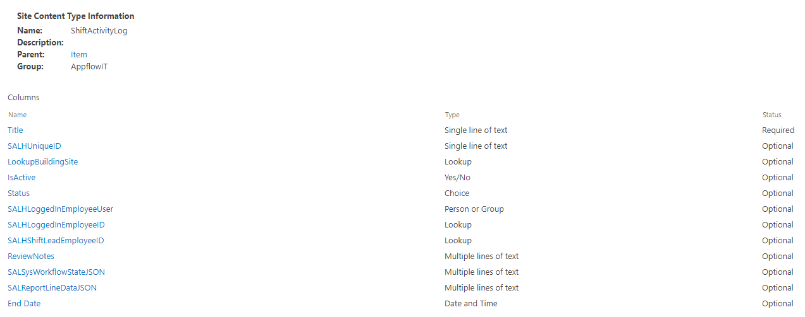

### Lists

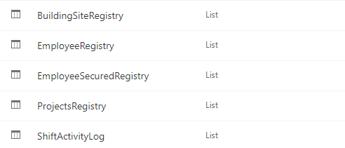

## FORMS – SCREEN Drawings + PowerApps

### Listing View - screen

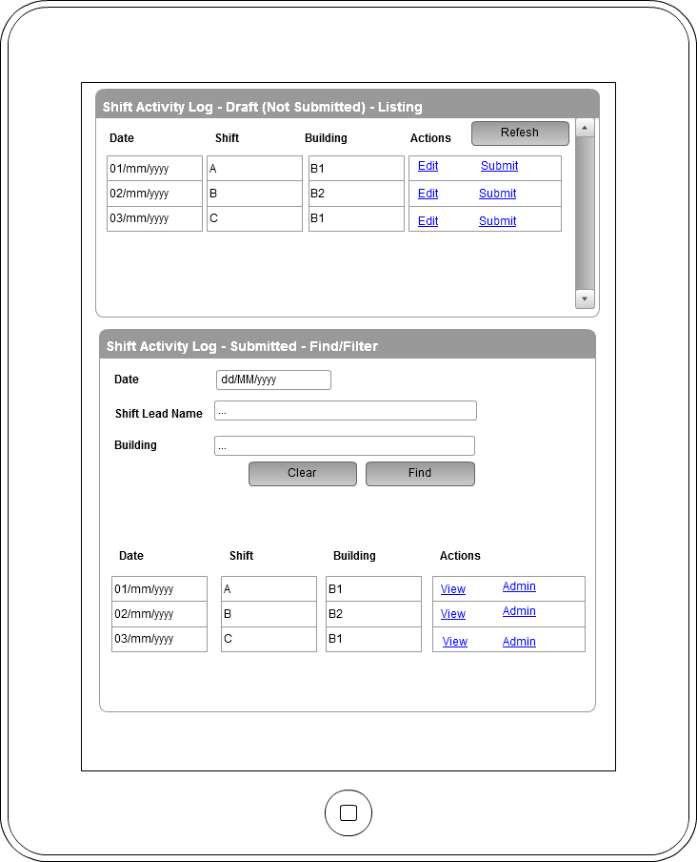

### New and Edit - Screen

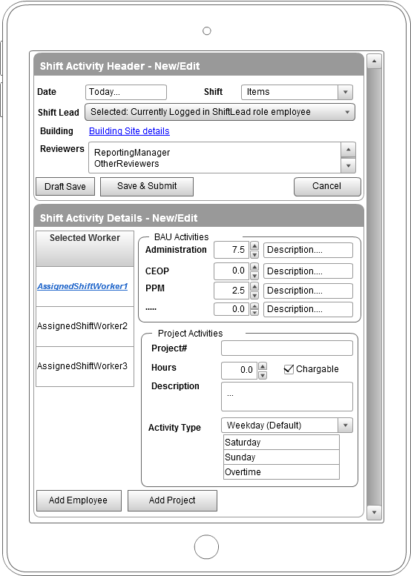

### Review and Approval - Screen

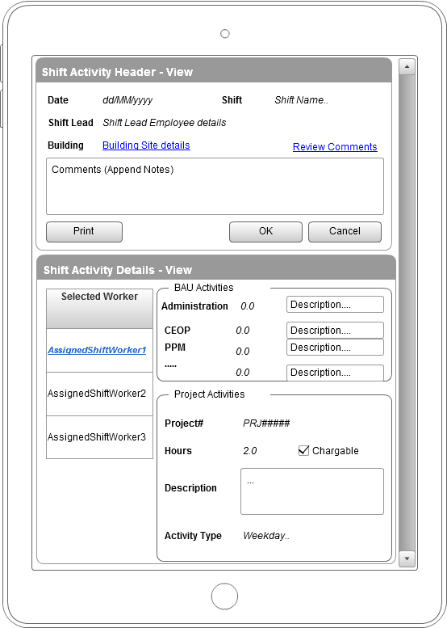

## AUTOMATION – MS-FLOW/WebJobs/LogicApps/Functions/CUSTOM-CONNECTOR

### **One-off Data Migration from Excel**

  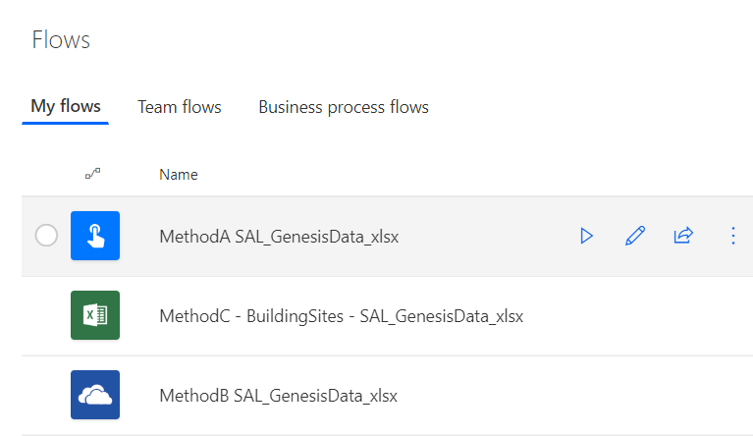

### **Load data for logged in user Flow to PowerApps**

### **Save data from PowerApps to SharePoint/etc. through Flow**

## Reporting - POWERBI

# SUPPORT – ENVIRONMENT – TOOLS – CONFIGURATION

## TOOLS

1. SOAPUI: Download and Install OSS(free) version from - <https://www.soapui.org/downloads/soapui.html>
2. **POSTMAN**: Download and install for Chrome from - <https://www.getpostman.com/download?platform=win64>
3. CAML-QUERY:
   1. <https://saketa.com/sharepoint-caml-query-builder/>
   2. [https://**www.biwug.be**/resources](https://www.biwug.be/resources)

## CONFIGURATION: A

# HOPE THIS HELPED!?

Kindly feedback your thoughts and suggestions and ideas, that would be magical to get them😊

Cheers, Aaseaf Mahkahti | [sharepointjob@outlook.com](mailto:sharepointjob@outlook.com)

{

"SALRDUniqueID":"",

"SALRDDate":"",

"SALRDBuildingSiteCode":"",

"SALRDWorkerFullName":"",

"SALRDWorkerPayrollNumber":"",

"SALRDWorkerJobTitle":"",

"BAUHoursAdministration":"",

"ActivityHoursCEOP":"",

"ActivityHoursProjectSupport":"",

"ActivityHoursOther":"",

"ActivityHoursPlantChecks":"",

"ActivityHoursPPM":"",

"ActivityHoursReactiveTasks":"",

"ActivityHoursSmallWorks":"",

"ActivityHoursTraining":"",

"TotalActivityBAUActivityHours":"",

"CommentsDescriptionsActivityHours":"",

"WorkerProjects": [

{

"IsProjectActivityActivated":"",

"IsProjectActivityChargeable":"",

"ProjectNumber":"",

"ProjectIFNCode":"",

"ProjectActivityHours"

"ProjectActivityCategory":"",

"ProjectActivityDescription":"",

"":"",

"ChargeRateCosting":""

}]

}

EmployeeRegistry, EmployeeSecureRegistry, BuildingRegistry 🡺 ProjectsRegistry

Work break down:

1. Prepare excel workbook for initial migration/dataload …. Prepare “approach” to read this excel and do the dataload: WebJob? / Azure-Function? / LogicApp?/Flow?
2. Create PowerApps form design
3. Create Scheduled timesheet record generator based on all sorts of business logic – WebJob?/Functions?/LogicApp
   1. Refer to the farmsol – timerjob
4. Tie up PowerApp and Flow together to make working app
   1. User logs in: decide if they are Shift-Lead or Shift-Worker and accordingly fetch data + show-hide controls which is to map/bind JSON data schema to control..
   2. User does data entry and saves not before validations are done – and LocalSave is enabled for intermitent-internet scenarios…
   3. Shift Manager can review and approve
5. Reports generation with PowerBI … heck:- how to convert JSON data to Tables => PowerQuery??